Assignment 4
Flight Booking Using Spring WebFlux
Important Screenshots
SonarQube Analysis (Before) :-
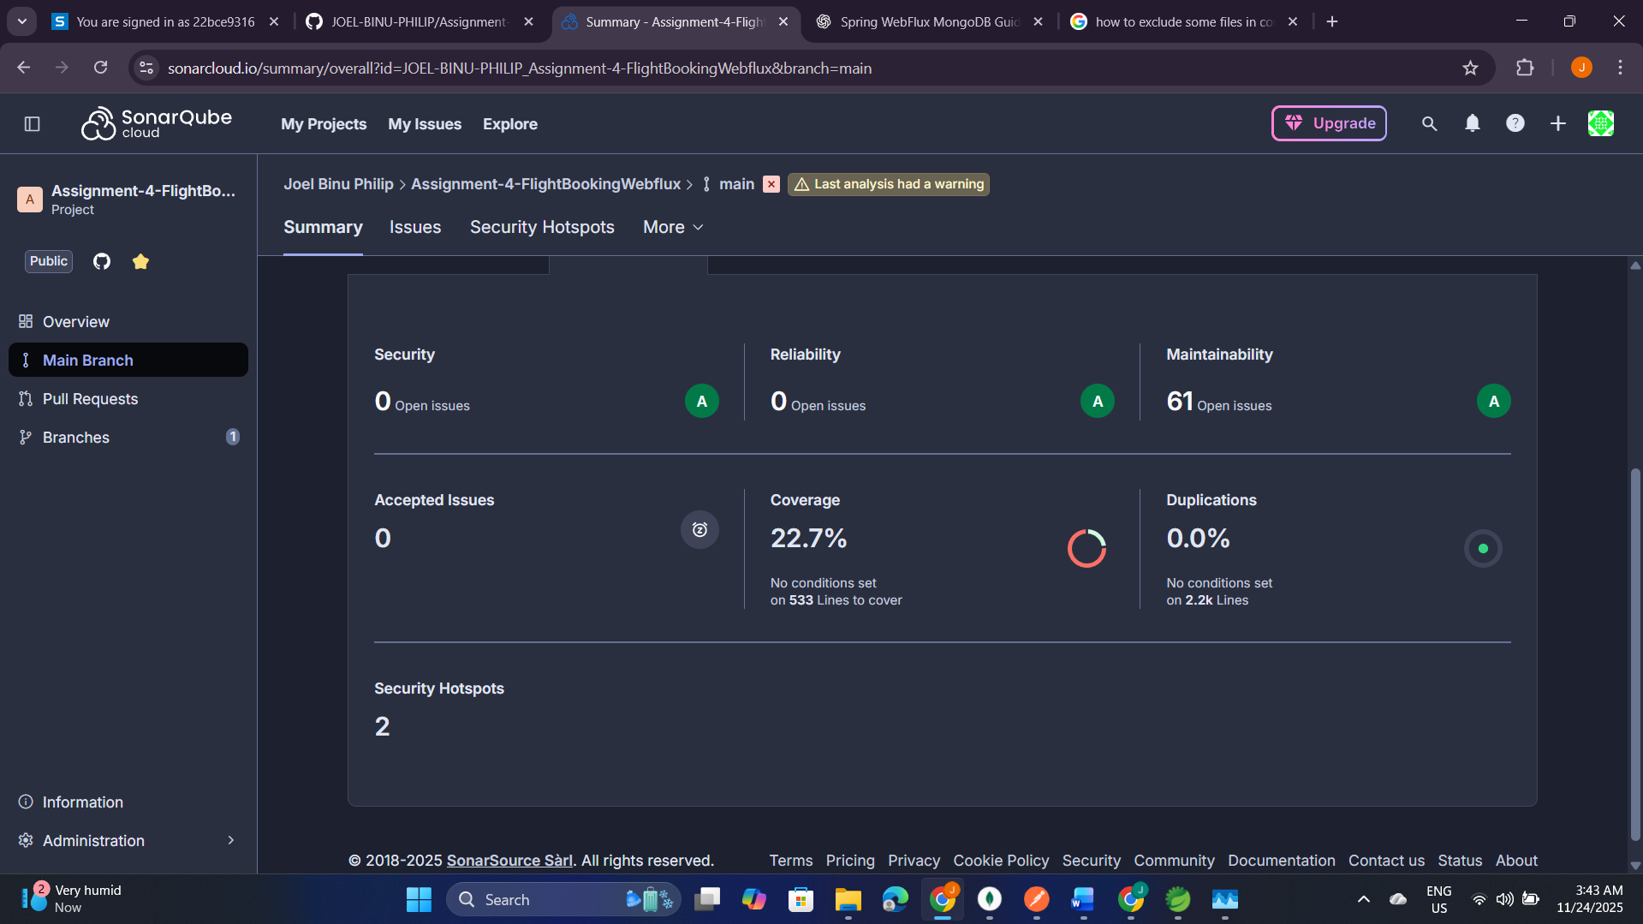

SonarQube Analysis (After) :-
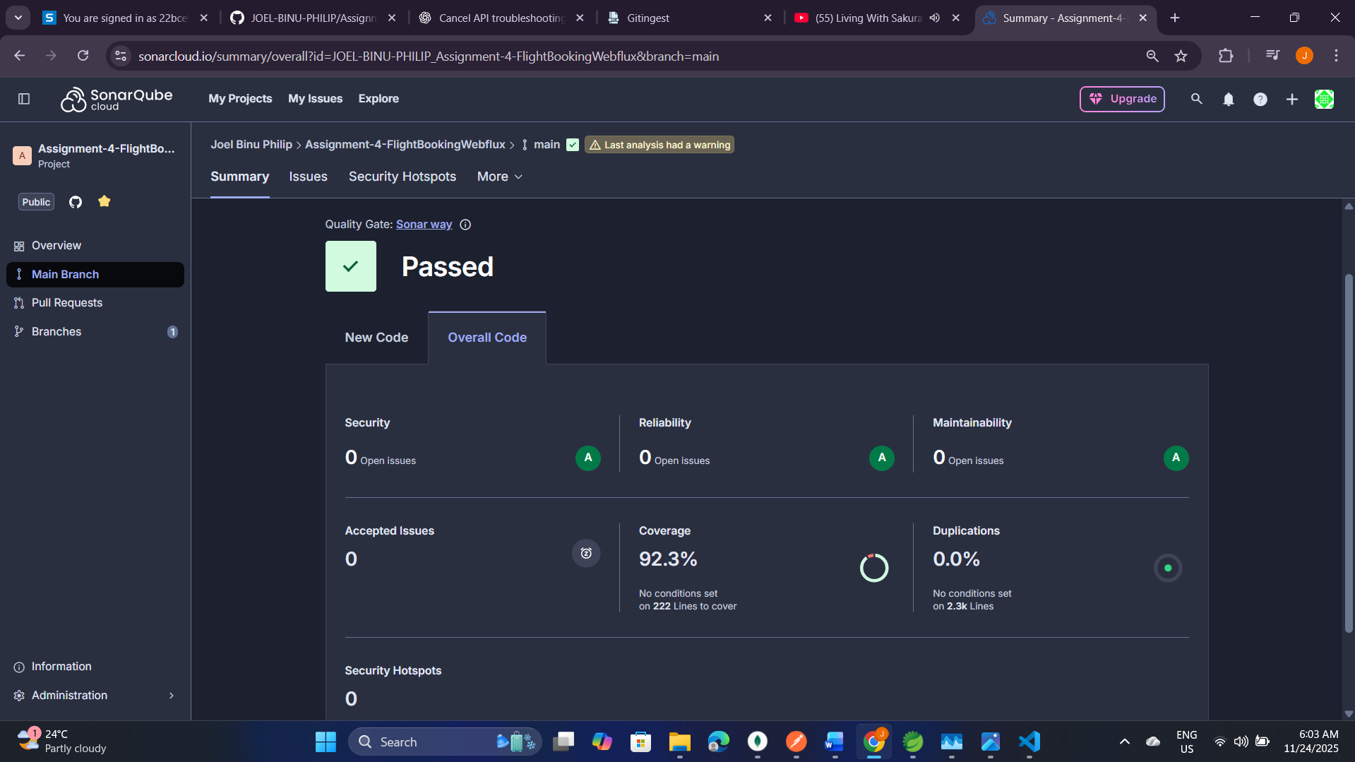
J Meter Results Summary for 20 Requests
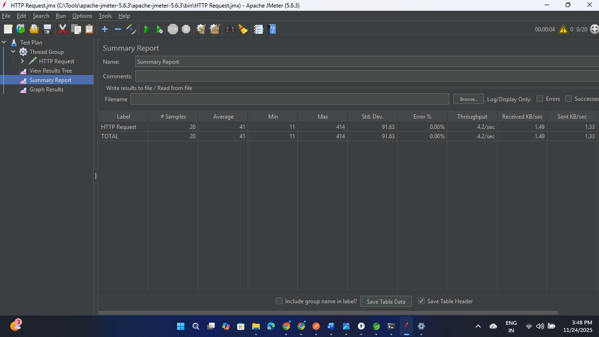
View Results Tree
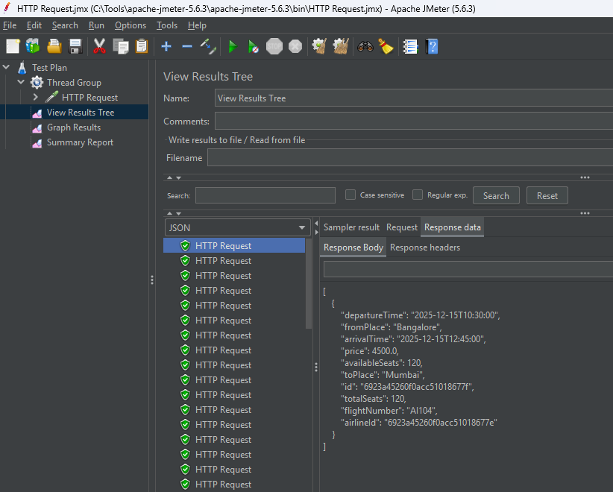
J Meter Results Summary for 50 Requests
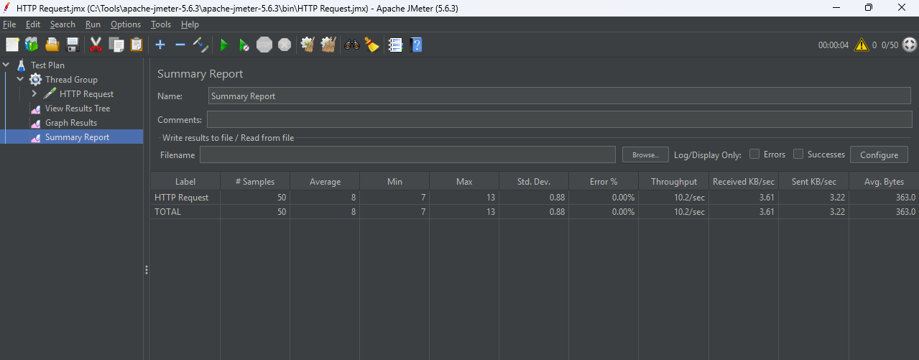
Jmeter Results summary for 100 Requests
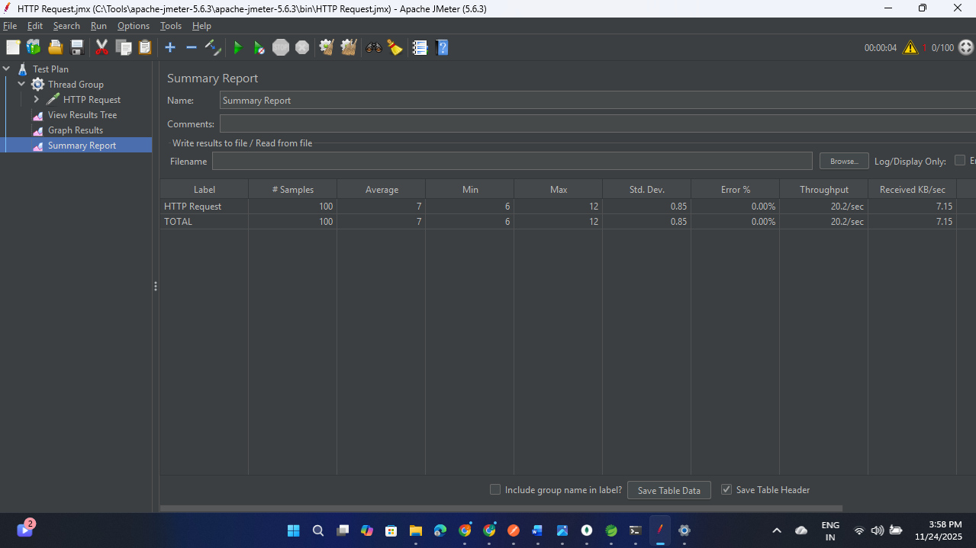
MongoDB Collections
